EXP 2
P Sharweshvar

240701491

Forms Design Using Zoho Creator

AIM
To create and manage student-related forms using Zoho Creator for storing student profile, academic, guardian contact, and course enrollment information.

PROCEDURE
- Create a new application named Student Management System in Zoho Creator.
- Create the following four forms:
  - Student Profile – to store basic student details such as Student ID, Name, Date of Birth, Gender, Email, Phone Number, and Address.
  - Academic – to store academic details such as Student ID, Department, Semester, CGPA, Attendance, and Academic Year.
  - Guardian Contact – to store guardian information such as Guardian Name, Relationship, Contact Number, Email, and Address.
  - Course Enrollment – to store course enrollment details such as Student ID, Course Name, Course Code, Semester, Enrollment Date, and Faculty Name.
- Add suitable field types such as Single Line, Number, Email, Phone, Date, Dropdown, and Radio fields.
- Configure the required fields and arrange the fields appropriately.
- Enter sample student records into each form.
- Preview and verify all the forms to ensure that the data is entered and stored correctly.

OUTPUT
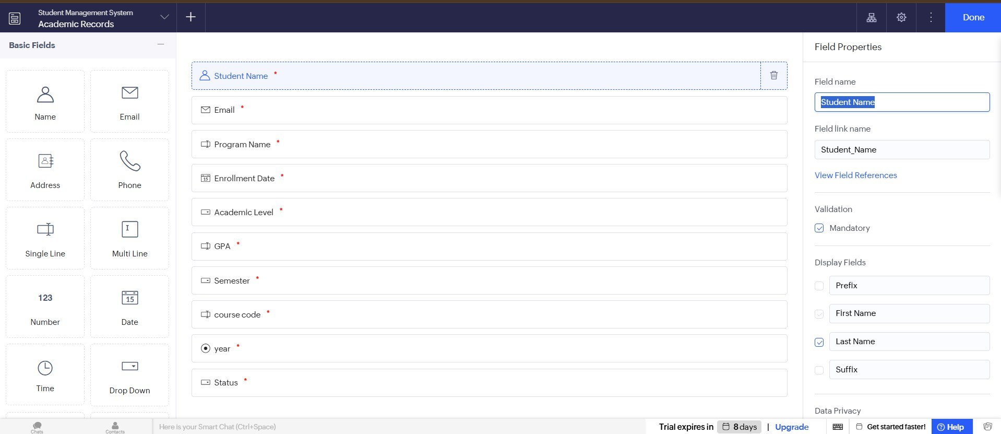

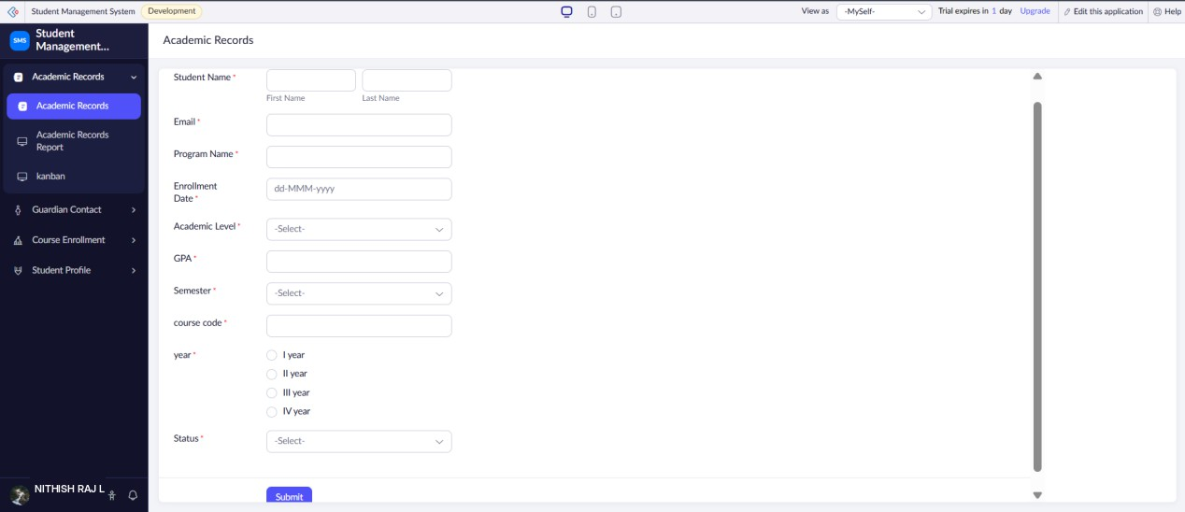
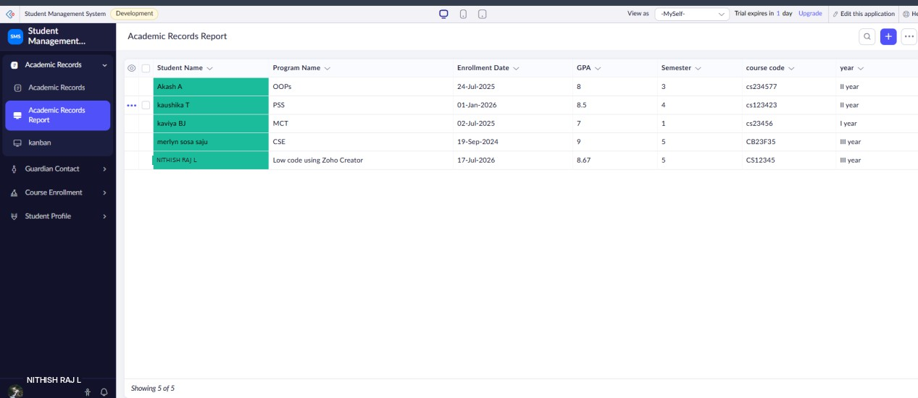

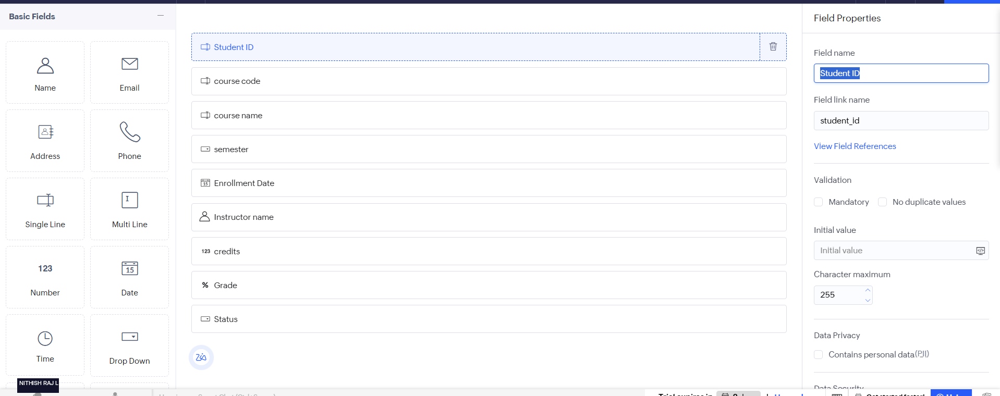
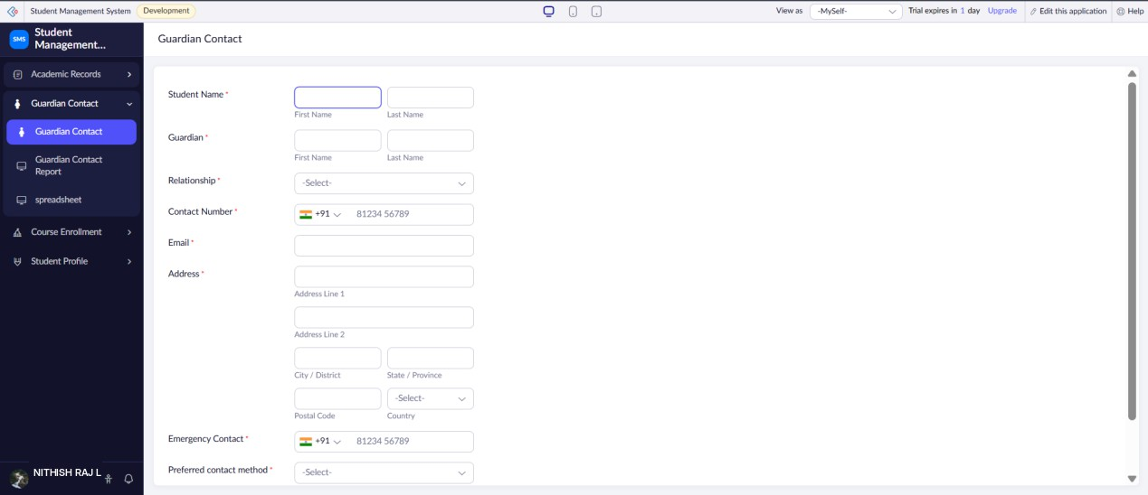
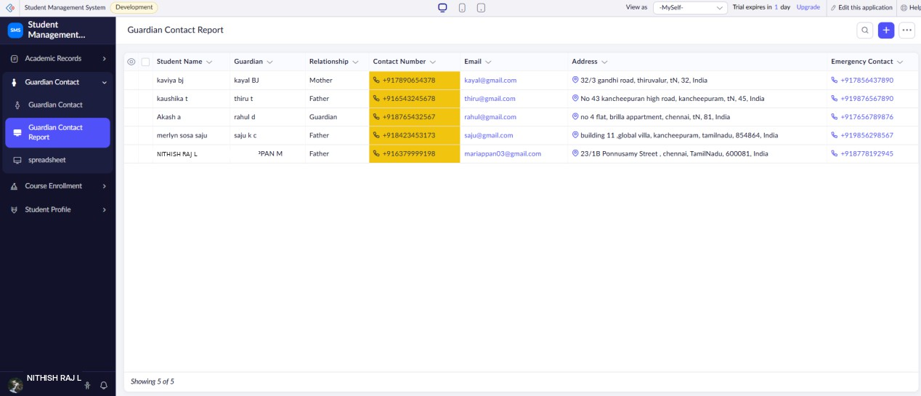

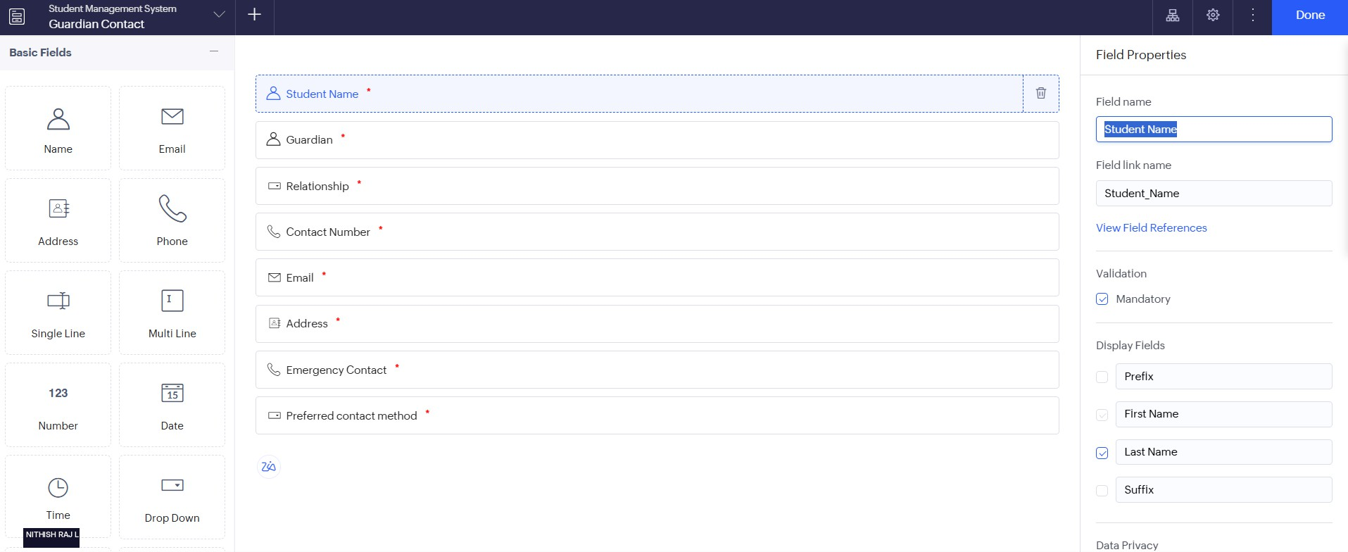
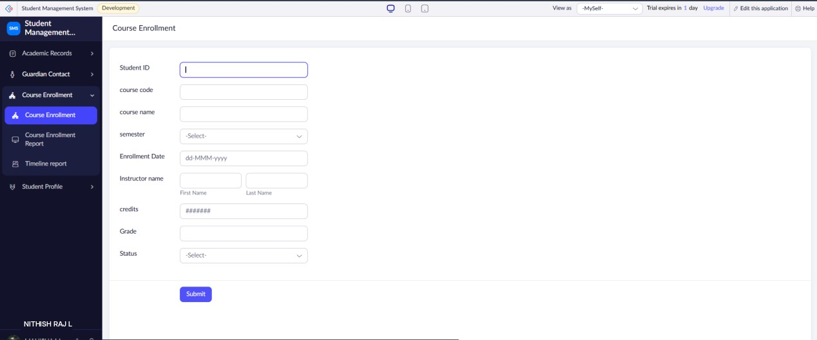

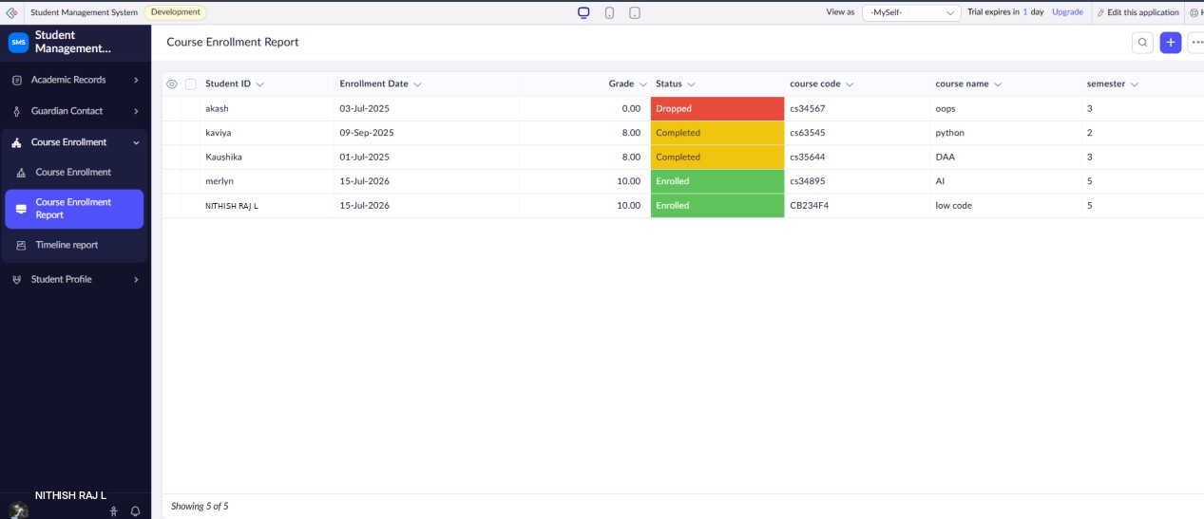

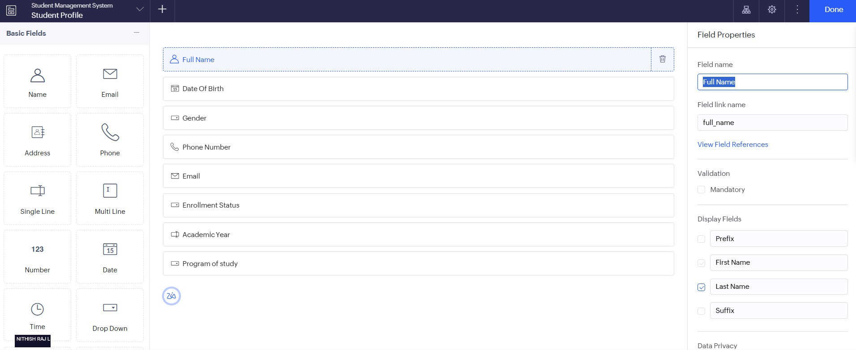
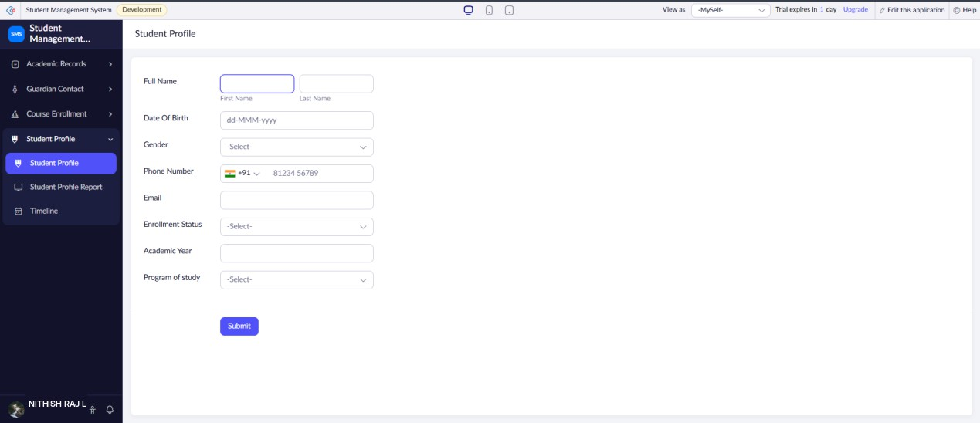

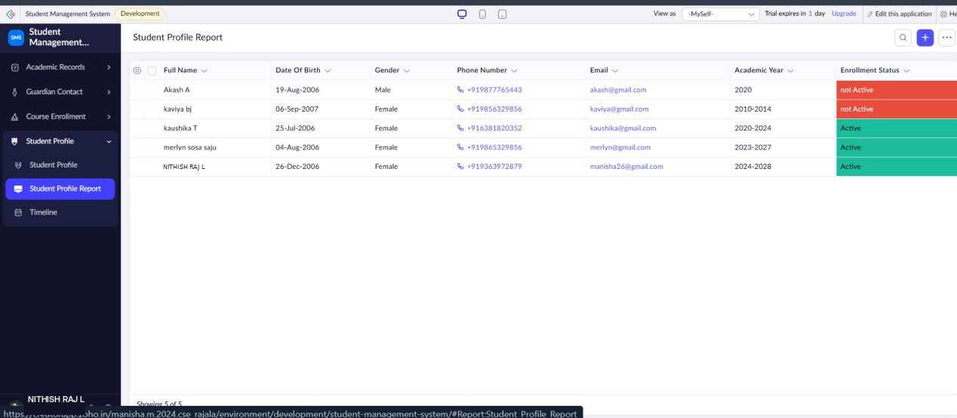

RESULT
Thus, the required Student Profile, Academic, Guardian Contact, and Course
Enrollment forms were successfully created in Zoho Creator and sample student data was stored successfully.

